Site Url: <https://legacydocs.hubspot.com/docs/methods/contacts/batch_create_or_update>

This site shows documentation for HubSpot API. You can enter the site and see the API body structure in JSON format.

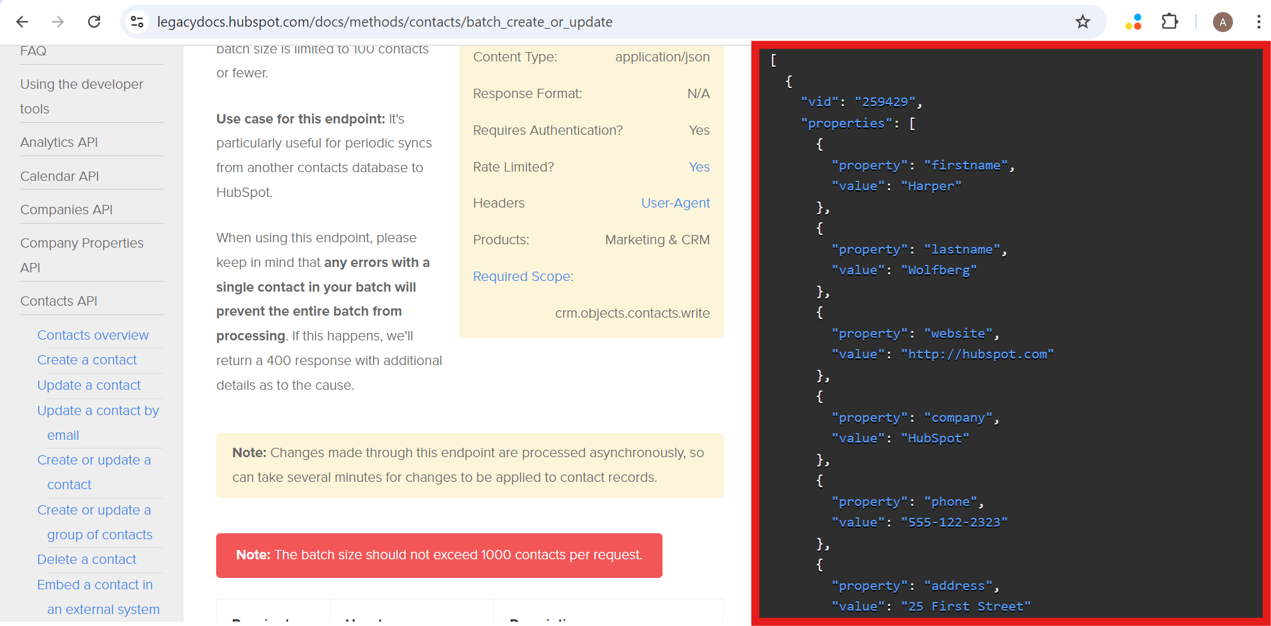

The contact’s data is stored in SQL Server as tabular format.

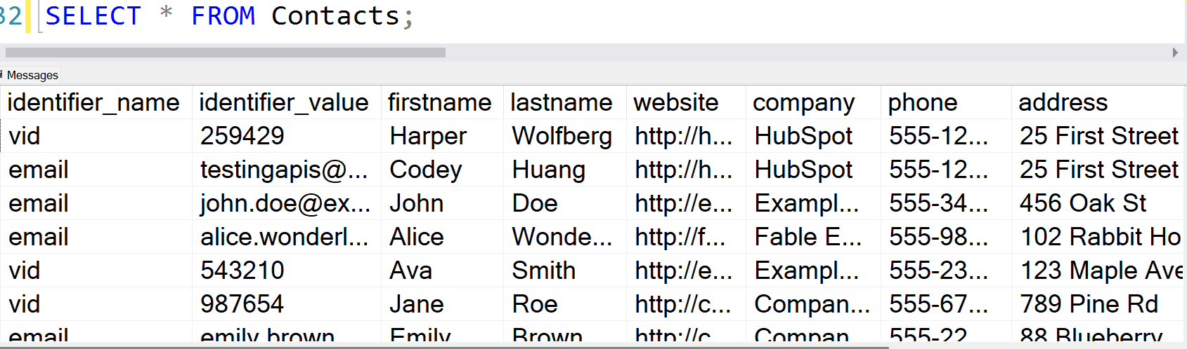

The first two columns (**identifier_name** and **identifier_value**) represents contact identifier and all the other columns shows contact properties.

You have to write SQL query to transform the data to JSON format. The output must be exactly the same with the JSON format in the website. The number of columns for properties can be different from this sample that is it can be less or more. For example, there can be “**street**” column added to the table. So, the query must be dynamic and work for any number of columns.

Restrictions: **while loop** and **cursor** are not allowed.